### TRANSPORT IN ANIMALS

Unicellular animals have maximum surface area to volume ratio; and most of the substances move into or out of their bodies by simple difusion, osmosis, active transport, and facilitated difusion. So there are no special transport systems involved. Same is true of simple multicellular animals which are aquatic. But complex multicellular animals possess highly organized, and well developed transport system, in the form of blood vascular system.

#### Transportation in *Hydra*

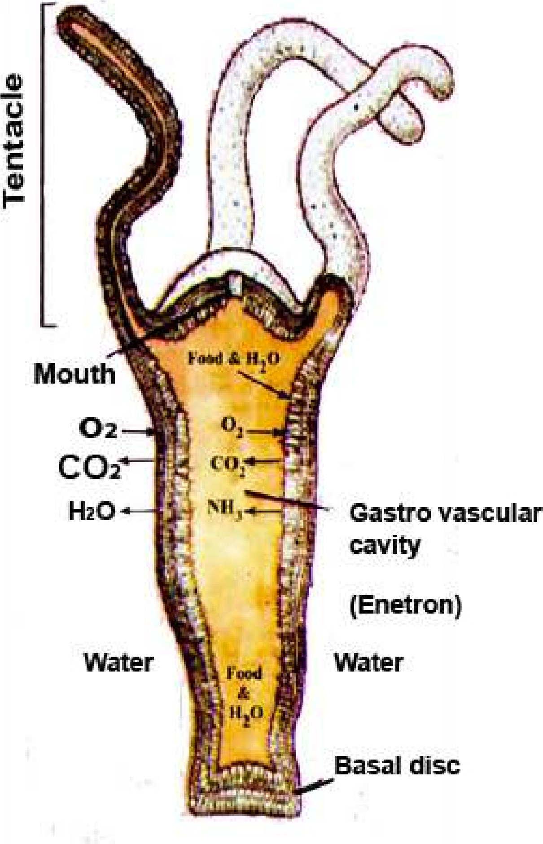It is fresh water in habitat. The body is two layered; the outer ectoderm and inner endoderm; in between them is mesogloea which is non-cellular. The outer surfaces of the ectoderm cells are exposed to the water in which the animal lives. Water, dissolved 02, and food is taken into the coelenteron(enteron) of Hydra by the movement of tentacles, and lagella which are present in most cells of endoderm.

The materials and food may be absorbed or taken up by endocytosis into endodermal cells. The indigestible and partly digested food is removed by exocytosis from these cells, into digestive cavity (coelenteron). Ectodermal cells get food from endodermal cells by difusion.

The ectodermal cells directly exchange materials with the surrounding water (Fig 14.14). They also get nutrients from endodermal cells.

*Fig.14.14 Hydra*

#### Transportation in *Planaria*

The body of Planaria is lat, so the most of its cells are exposed to the outer water. Difusion is the process involved in the movement of materials into and out of the cells.

There is no special transport system in Planaria. The reasons are:

1. The body of Planaria is lat, and provides greater surface area for the exchange of materials, between the body and the environment.
2. Planaria is acoelomate i.e. there is no body cavity and the mesodermal layer or mesenchyme is composed of loosely packed cells between ectoderm and endoderm. Whatever materials, such as 02, difuse in the ectoderm, pass to mesoderm cells and then difuse into endoderm cells. For the removal of wastes the same route is reversed. Intestinal caecae reach near almost every cell of the body and digested food is provided to the cells by difusion. The endoderm cells, can also acquire food, water, dissolved minerals, and to some extent 02. and remove wastes into the gut.

### CIRCULATORY SYSTEM

In the body of larger and complex animals, there is very little exposed surface area to volume ratio. Most of the cells are not exposed to the external environment directly and it becomes very diicult to transport materials by simpl difusion. Complex animals have evolved transport systems in the form of blood vascular system or circulatory system.

#### Characteristics of Circulatory System

A circulatory system accounts for rapid mass low of materials from one part of the body to the other, where difusion would be too slow.

There are three characteristics of a circulatory system.

1. A circulatory luid - the blood.
2. A contractile pumping device - which may be the modiied blood vessel or a heart.
3. Tubes, which can transport the circulatory luid (blood) to and from cells of the body These tubes are the blood vessels. Materials must be exchanged between the circulatory luid and other body cells.

#### Open and Closed Circulatory System

The circulatory systems of animals are divided into two main types:

1. **Open circulatory system:** It is observed in animals belonging to Phylum Arthropoda (crustaceans, spiders, insects) and Phylum Mollusca (snails and clams) and group of protochordates, the tunicates.
2. **closed circulatory system:** It is observed in animals belonging to annelids,cephalopod molluscs (squids and octopus), echinoderms and vertebrates.

|  |
| --- |
| *Animation 14.7*[*: Circulatory System*](https://www.youtube.com/watch?v=Dtsen_YNwVk) *Source and Credit:* [*t*](https://www.youtube.com/channel/UCq4OErD4v1bo3dg0agqUC6g)[*echnostrikers*](http://technostrikers.weebly.com/4/post/2013/10/the-circulatory-system.html) |

The diferences between open circulatory system and closed circulatory system would be clear by studying the comparison between circulartary systems of earth worm and cockroach, (see table 14.1).

**Table 14.1 Comparison between closed and open circulatory systems.**

|  |  |
| --- | --- |
| **Closed circulatory system e.g. Earthworm (*Pheretima*)** | **Open circulatory system e.g.**  **cockroach (*Periplaneta*)** |
| 1. Blood always remain in the blood vessels, and does not come in direct contact with other cells of the body. | 1. Blood does not remain enclosed in the blood vessels and comes in direct contact with other body cells, and bathes them. |
| 2. Inter connected system of arteries , veins, and capillaries present. | 2. There are no typical arteries, veins, and capillaries and for much of the time the blood called haemolymph lows in the cavities or sinuses of body cavity (hoemocoel) around the viscera (perivisceral sinus) and around the nerve cord (perineural sinus). |
| 3. Exchange of nutrients and waste products between the blood and tissues via tissue luid occurs through capillaries. | 3. Exchange of nutrients and waste products between the blood and tissues occurs when blood directly bathes the tissues. |
| 4. The system also transports gases i.e. oxygen and carbon dioxide. | 4. This sytem does not transport gases i.e. oxygen and carbon dioxide (these gases are transported by tracheal system). |
| 5. Respiratory pigment haemoglobin is dissolved in blood. Nucleated white blood cells are present. | 5. No respiratory pigment and blood is colourless in which nucleated white blood cells loat. |
| 6. This is regarded as the most advanced type, having greater eiciency, maintaining the blood pressure and economy of blood volume. | 6. This is regarded as primitive having lesser eiciency and does not maintain blood pressure. |
| 7. In earthworm there are 4 or 5 pairs of lateral hearts present on the lateral side of oesophagus in 7th to 13th segments. Hearts pump the blood from the dorsal to the ventral blood vessel. | 7. In cockroach the heart is 13-chambered, tubular vessel present in the pericardial sinus and placed in mid-dorsal region below terga in abdominal region. On the side of the pericardial sinus there are alary muscles helping in the low of blood. Each heart chamber has a pair of lateral openings, the ostia. |
| 8. There are three main longitudinally running blood vessels, dorsal, ventral and sub-neural, which are interconnected through capillaries and commissural vessels. | 8. The portion of the tubular dorsal vessel which extends in the thoracic and head region is called the “aorta”. It opens anteriorly in the haemocoel of the head by funnel shaped opening. |

|  |  |
| --- | --- |
| 9. The dorsal vessel collects blood from the 14th segment backwards. In the irst 13 segments it becomes distributing channel and sends its blood to hearts and anterior end of the body. Ventral vessel is the chief distributing vessel with backward low.The subneural vessel is collecting vessel and the low of blood is backwards. It communicates with dorsal blood vessel through commissural vessels. | 9. The low of blood from heart to, aorta to, haemocoel in head, to perivisceral sinus, to perineural sinus, to pervisceral sinus, to pericardial sinus, and to heart through ostia. |

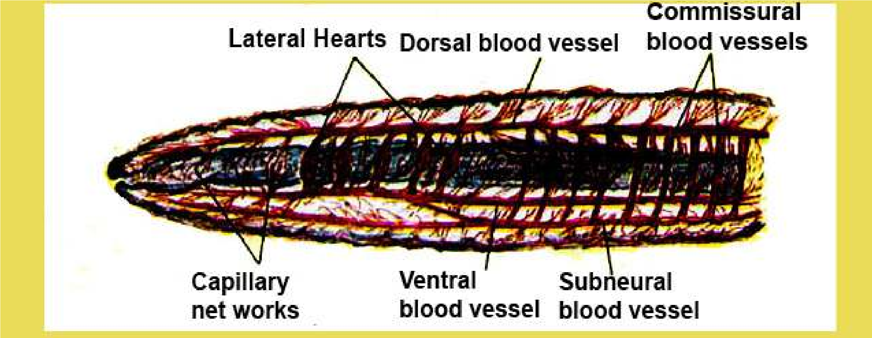

*Fig. 14.15 Closed circulatory system of earthworm*

*Animation 14.8*[*:*](https://www.youtube.com/watch?v=Dtsen_YNwVk) *Closed circulatory system of earthworm Source and Credit:* [*w*](https://www.youtube.com/channel/UCq4OErD4v1bo3dg0agqUC6g)*aterwereld*

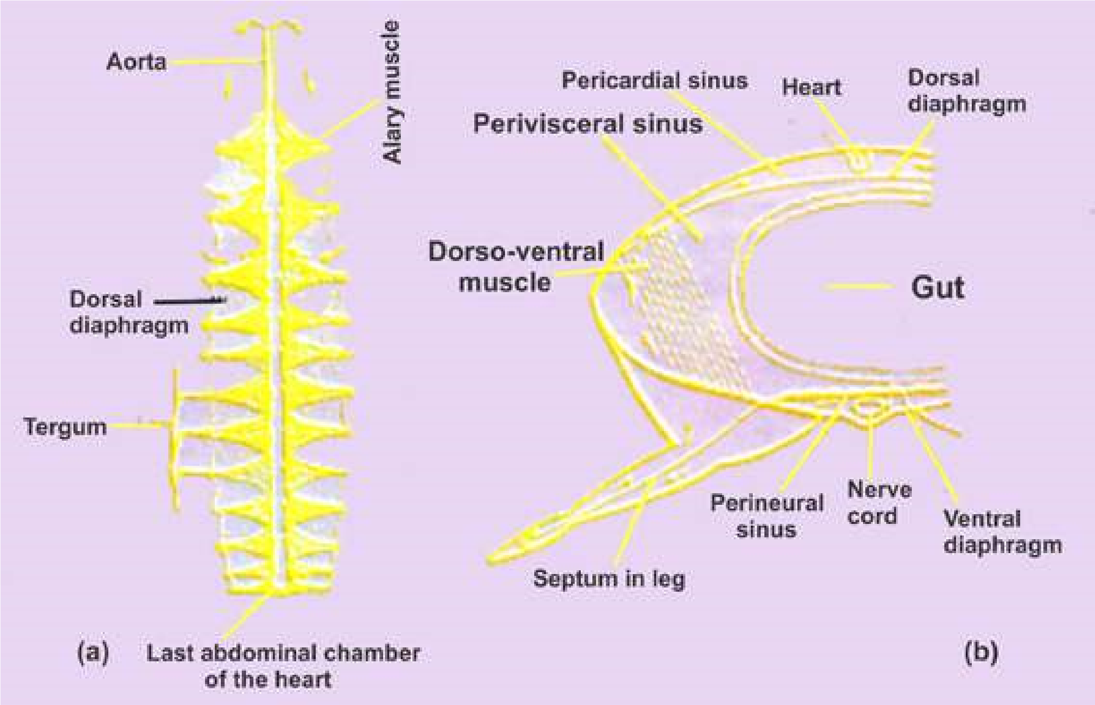

*Fig.14.16 Open circulatory system of cockroach, (a) The heart with alary muscle and dorsal diaphragm, (b) T.S of cockroach through thorax showing various sinuses.*

#### Vertebrate blood circulatory system

The components of vertebrate blood vascular system are typical of a circulatory system-blood, heart, blood vessels (arteries, capillaries and veins). All vertebrates have closed circulatory system In addition there is lymphatic system which also aids in transportation.

Heart pumps the blood to diferent parts of the body via aorta and arteries Arteries break into ine blood vessels, the capillaries. These join to form veins which bring blood back to the heart. The capillaries are sites where exchange of materials between blood and body tissues takes place.

#### Evolution of vertebrate heart

The heart of ishes have sinus venosus, an atrium, a ventricle, and bulbus arteriosus or conus arteriosus. Sinus venosus receives deoxygenated blood from the body,and then blood is passed to atrium, which on contraction passes it to ventricle. ventricle has thick muscular wall. When the muscles of ventricle contract, they push the blood via conus arteriosus or bulbous arteriosus (proximal swollen portion of ventral aorta).

Thus the heart of fishes works as a **single circuit heart**. The blood flows in one direction only, from sinus venosus to atrium then to ventricle *The heart of the ishes never receives oxygenated blood.* and to ventral aorta via bulbus arteriosus or conus *It is only the deoxygenated blood which passes through* arteriosus to the gills and then to the body. The *diferent chambers of the heart. (Fig. 14.18 a). The valvespresent in the heart control the low of blood in single* blood returns to the heart in the sinus venosus The *direction i.e. sinus venosus —> atrium —> ventricle conus* oxygenated blood is supplied from dorsal aorta *arteriosus —> ventral aorta —> gills —> dorsal aorta —body —» sinus venosus. So the heart of ishes functions as»* through coronary arteries,to the heart and is carried *a single circuit heart.* back by coronary veins from the heart).

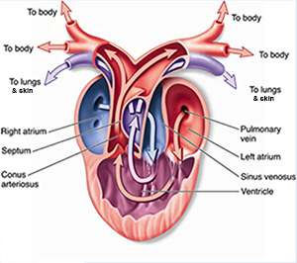In amphibians the heart is three chambered with regard to auricles and ventricles.There are two auricles and one ventricle. In addition, sinus venosus and truncus arteriosus are also present. Sinus venosus receives de-oxygenated blood from two superior venacavae (precavals) and one inferior vena cava (postcaval) from diferent parts of the body. This blood passes to the right auricle. The oxygenated blood from lungs is poured via pulmonary veins into left auricle. Both auricles contract simultaneously and blood is passed into the ventricle. There is a complete mixing of oxygenated and deoxygenated blood in the ventricle. When ventricle contracts, it pushes blood via truncus arteriosus, to two carotids, two systemics, and two pulmocutaneous arches.

(Fig. 14.19b).

*Fig. 14.17 Structure of heart of frog*

*Animation 14.9*

[*:*](https://www.youtube.com/watch?v=Dtsen_YNwVk)

*Structure of heart of frog*

*Source and Credit:*

*m*

*ultelear*

[*n*](http://www.multelearn.com/exercises/BiologyHome.htm)

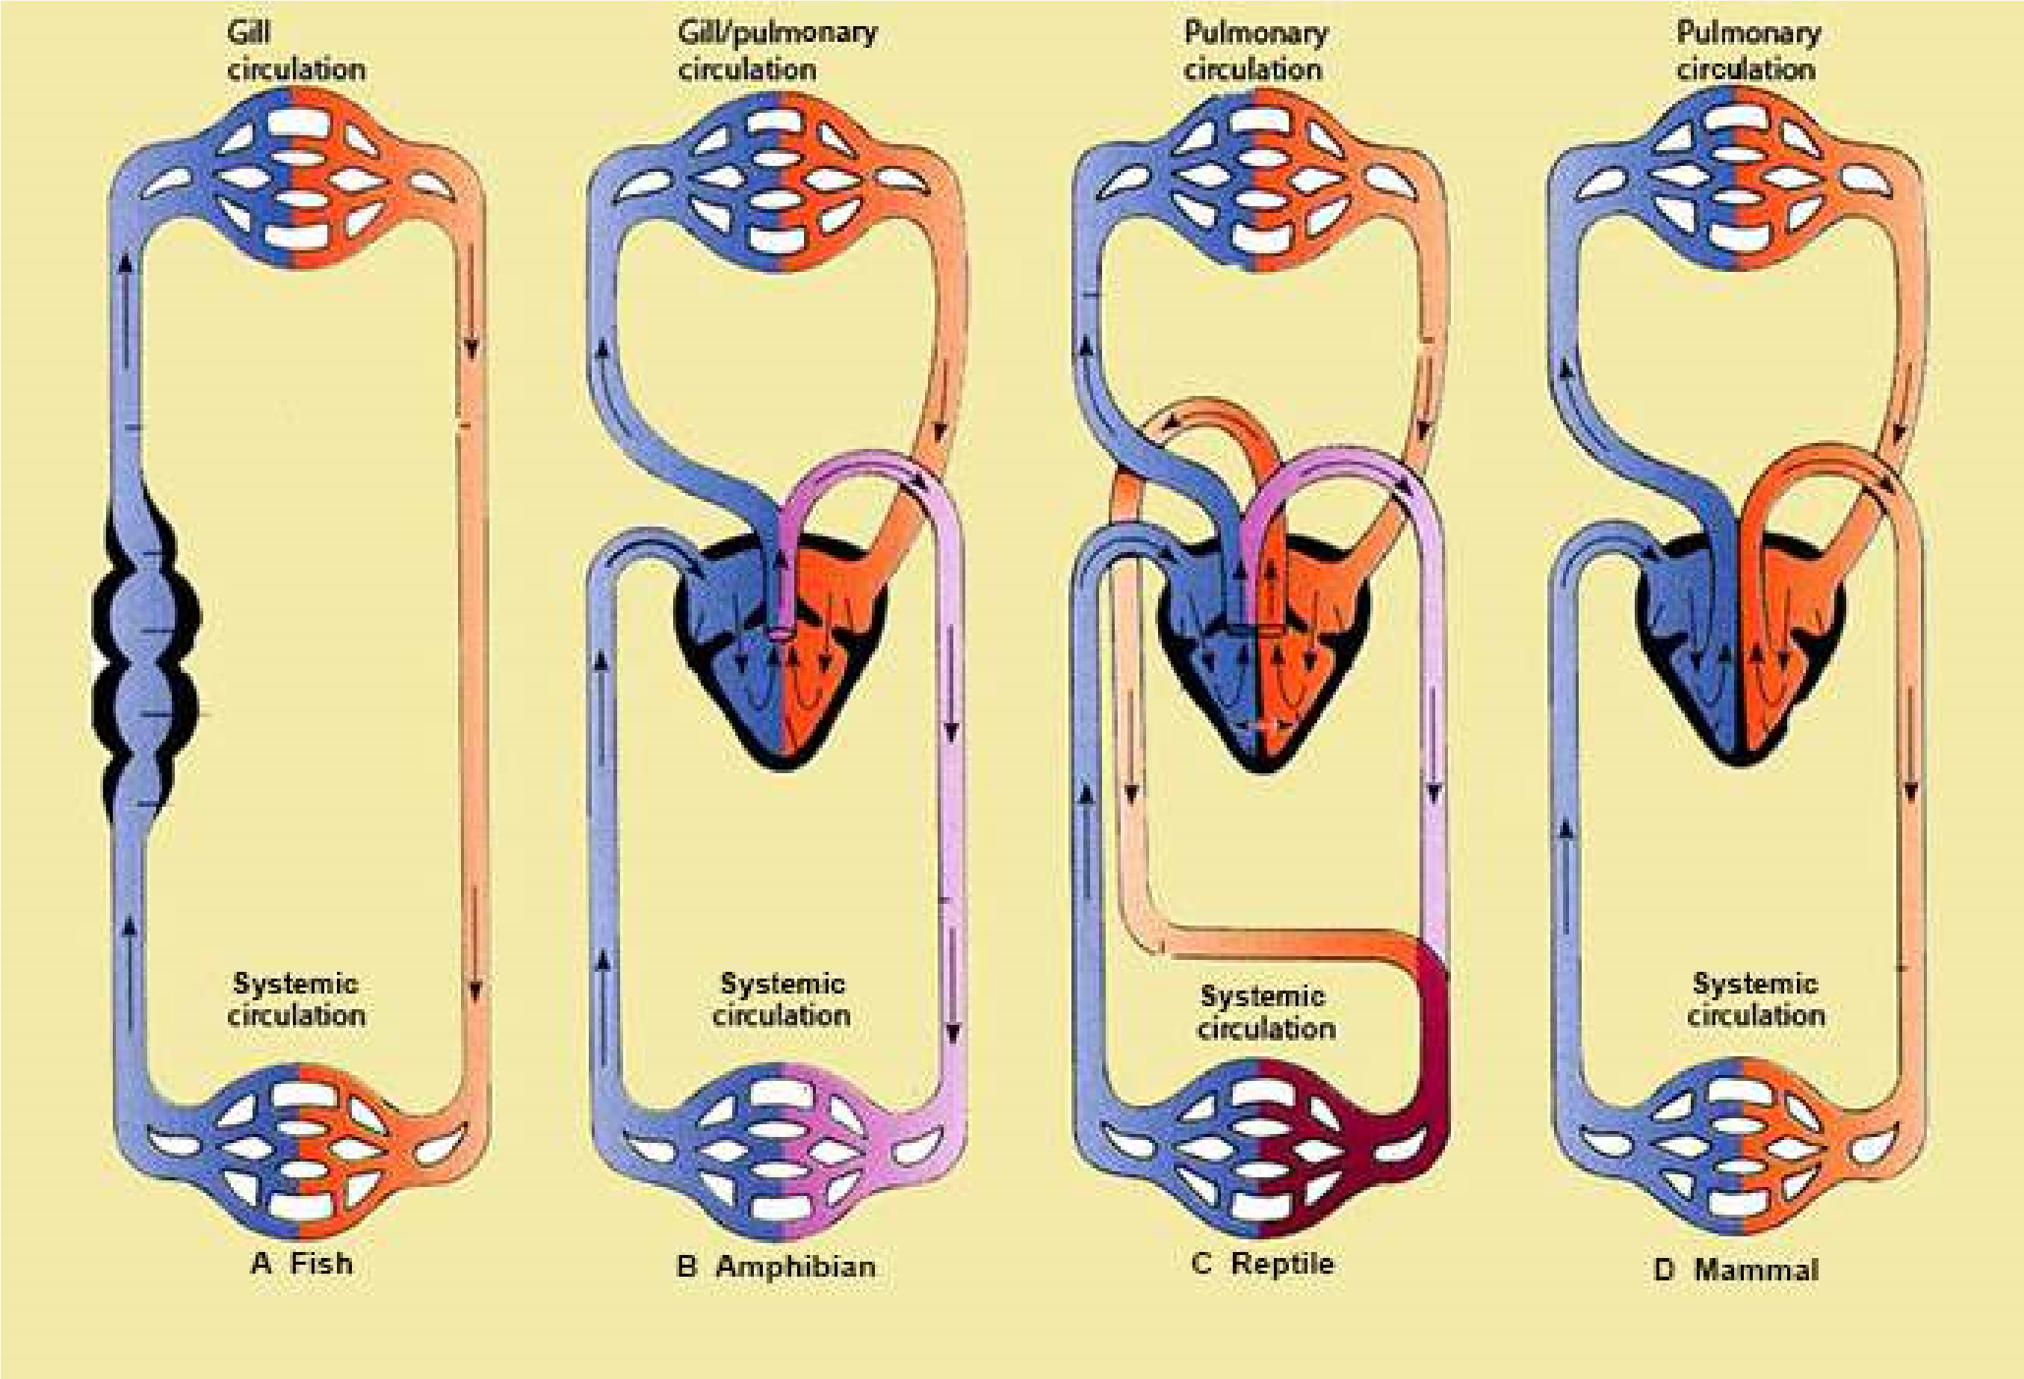

Fig.14.18 A schematic comparison of vertebrate heart and circulation of blood. (A) In modern ish the blood is pumped to the gills, where it picks up oxygen. The oxygenated blood (red) then passes without further pumping to the systemic circulation, where it gives up its oxygen before returning to the heart. (B) In amphibians the blood that has picked up oxygen in the gills and/or lungs returns to the heart, from which it is pumped into the systemic circulation. Extensive mixing (purple) of the pulmonary and systemic lows occurs in the heart. (C) In reptiles the pattern is much the same, except that the ventricles are partially divided, so less mixing takes place. (D) In mammals and birds the two halves of the heart are efectively separated.

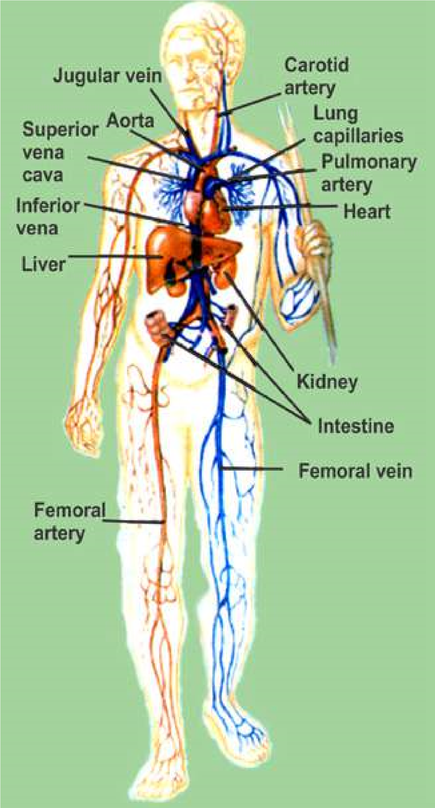The heart of reptiles and all other amniotes practically functions as four chambered heart. There are two auricles in the heart of reptiles. The reptiles have incompletely partitioned ventricle; but in crocodiles, the interventricular septum is complete and heart is four chambered. In all reptiles the left and right systemic arches carry oxygenated blood and arise from a region of ventricle called cavum venosum - into which left ventricle directs its blood. The deoxygenated blood from the right atrium is directed towards the entrance of the pulmonary trunk which is also located or starts from a pocket the cavum pulmonale, on right side of ventricle- in the animals (reptiles) which do not have completely divided ventricle. Although the two systemic arches start from the ventricle separately, they are also interconnected at their base by an opening. The heart of reptiles birds and mammals functions as **double circuit heart.** (Fig. 14.19c). In the birds and mammals, the heart is four - chambered, and oxygenated and deoxygenated blood does not mix at all. The pulmonary trunk arises from right ventricle and leads to the lungs.

The aortic trunk emerges from the left ventricle and leads to carotid and systemic arches. The left systemic disappears in birds and right systemic, most of it, disappears in mammals. (Fig. 14.19 D).

In reptile, birds and mammals, as a result of these modiications, all blood returning to the right side of the heart passes to the lungs. After oxygenation, blood returns to left atrium from the lungs via pulmonary veins. Left atrium passes this blood to left ventricle - which on contraction pumps it to diferent parts of the body, and again blood returns to right atrium (Fig.14.18D). **Pulmonary circulation** is by pulmonary arch carrying deoxygenated blood from right ventricle of heart to lungs, and the blood returns to left atrium after oxygenation via pulmonary veins.

Likewise the systemic arch distributes blood to diferent parts of the body, and then the blood from the body returns to the heart, in the right atrium via precaval and postcaval. This is **systemic circulation**. So the hearts of amphibians, reptiles, birds and mammals have

both pulmonary and systemic circulation. *Fig. 14.19 The human circulatory system*

**TRANSPORT IN MAN :**

In humans, in addition to blood circulatory system, there is also another transport system, the lymphatic system, described latter in this chapter.

##### Blood circulatory system

The circulatory system of humans have the same 3 basic components.

1. Circulating luid - the blood.
2. The pumping organ - the heart.
3. The blood vessels, arteries, capillaries and veins.

#### (A) The circulatory luid-the blood

The blood is the medium in which dissolved nutrients, gases, hormones, and wastes are transported through the body. It is made up of two main components, (i) plasma and (ii) cells or cell - like bodies (white blood cells, red blood cells, platelets). The weight of the blood in our body is about 1/12th of our body.

**(i) PLASMA :** It has been estimated that in a normal person plasma constitutes about 55% by volume of the blood, and cells or cell-like bodies about 45% by volume of the blood.

Plasma is primarily water in which proteins, salts, nutrients and wastes are dissolved. Water constitutes about 90% of plasma, 10% are dissolved substances. Most of the dissolved substances are maintained at a constant or nearly constant level, but others occur in varying concentrations.

The substances dissolved or present in plasma vary in their concentrations, with the condition of the organism and with the portion of the system under examination. The solutes can be divided into six categories:

Inorganic salts (ions) - Plasma proteins - Organic nutrients - Nitrogenous waste products - Special products being transported and gases which are dissolved.

1. **Inorganic ions or mineral ions.** Together the inorganic ions and salts make up 0.9 per cent of the plasma, of humans, by weight; more than two thirds of this amount is sodium chloride the ordinary table salt. Even if the total concentration of dissolved substances remains the same, shifts in the concentration of particular ion can create serious disturbances. The normal pH of human blood is 7.4; and it is maintained between narrow limits, because the change in pH would afect the chemical reactions of the body.
2. **The plasma proteins** constitute 7-9 percent by weight of the plasma. Most of these proteins are synthesized in the liver. Some of the globulins, called immunoglobulins or antibodies, are produced in response to antigens, by lymphocytes; and then are passed to plasma, and lymph.

The proteins like prothrombin acts as a catalyst in blood clotting process. Fibrinogen takes part in the blood clotting process. Immunoglobulins play important role in body’s defenses against disease.

1. **Organic nutrients in the blood** include, glucose, fats, phospholipids, amino acids and lactic acids. Some of them enter the blood from the intestine (absorption). Lactic acid is produced in muscles as a result of glycolysis, and is transported by blood to liver. Cholesterol is an important constituent, it is metabolized to some extent, but also serves as precursor of steroid hormones.
2. **Plasma also contains nitrogenous waste** products formed as a result of cellular metabolism. These products are carried from the liver where they are produced, to the organs from where they are removed i.e. kidneys. Urea and small amounts of uric acid are present in plasma.
3. **All the hormones** in the body are carried by blood - so they are present in the plasma.
4. **The gases** such as CO2, O2 are present in the plasma of the blood.

*Animation 14.10: Blood Circulatory system Source & Credit: my-ecoach*

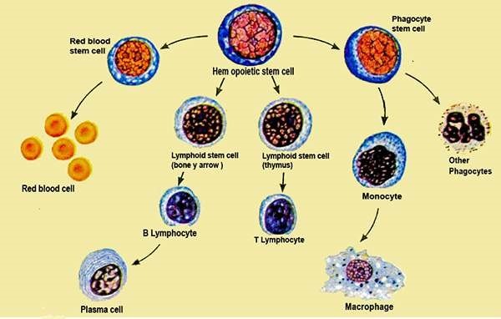

*Fig.14.20 Red blood cells (erythrocytes) and white blood cells (leucocytes) develop from stem cells in bone marrow.*

**(ii) BLOOD CELLS AND CELL LIKE BODIES :** These include red blood cells, (Erythrocytes), white blood cells (leucocytes) and platelets.

1. **Red blood cells (Erythrocytes) :** These are most numerous of the cells in the blood. A cubic millimeter contains 5-1/2 million of them in males, and 4-1/2 million in females. These cells, when formed, have nucleus, but it is lost before they enter the circulatory luid or blood. 95% of the cytoplasm of red blood cells is the red pigment, called haemoglobin the remaining 5% consists of enzymes, salts and other proteins. The red cells once mature, do not divide.

Red blood cells are formed principally in the red bone marrow of short bones, such as the sternum, ribs and vertebrae (Fig. 14.20). In the embryonic life, they are formed in the liver and spleen. The average life span of red blood cell is about four months after which it breaks down and disintegrates in the liver and spleen - partly by phagocytes by phagocytosis (Table -14.2)

1. **White blood cells (Leucocytes):** These blood cells are colourless, as they do not contain pigments. One cubic millimetre of blood contains 7000 to 8000 of them. They are much larger than the red blood cells. There are at least ive diferent types which can be distinguished on the basis of the shape of the nucleus and density of granules in the cytoplasm (Table 14.2). They can be grouped into two main types, granulocytes and agranulocytes. Granulocytes, include neutrophils, eosinophils and basophils. They are formed in the red bone marrow (Fig. 14.20). Agranulocytes are formed in lymphoid tissue, such as those of the lymph nodes, spleen, tonsils, adenoids and the thymus. Agranulocytes include monocytes and lymphocytes (B and T). Monocytes stay from 10- 20 hours in the blood, then enter tissues and become tissue macrophages, performing phagocytic function (Fig. 14.24) Lymphocytes have life spans of months or even years; but this depends on the body’s need for these cells.

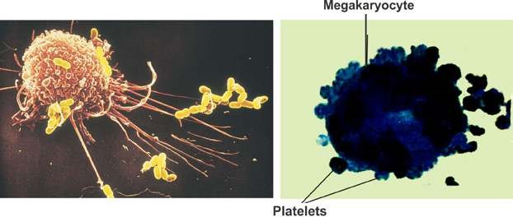

*Fig. 14.21 A macrophage in Action Fig. 14.22 The production of platelets*

*Animation 14.11*[*: white blood cells*](https://www.youtube.com/watch?v=Dtsen_YNwVk)

*Source and Credit:* [*g*](https://www.youtube.com/channel/UCq4OErD4v1bo3dg0agqUC6g)*ifsoup*

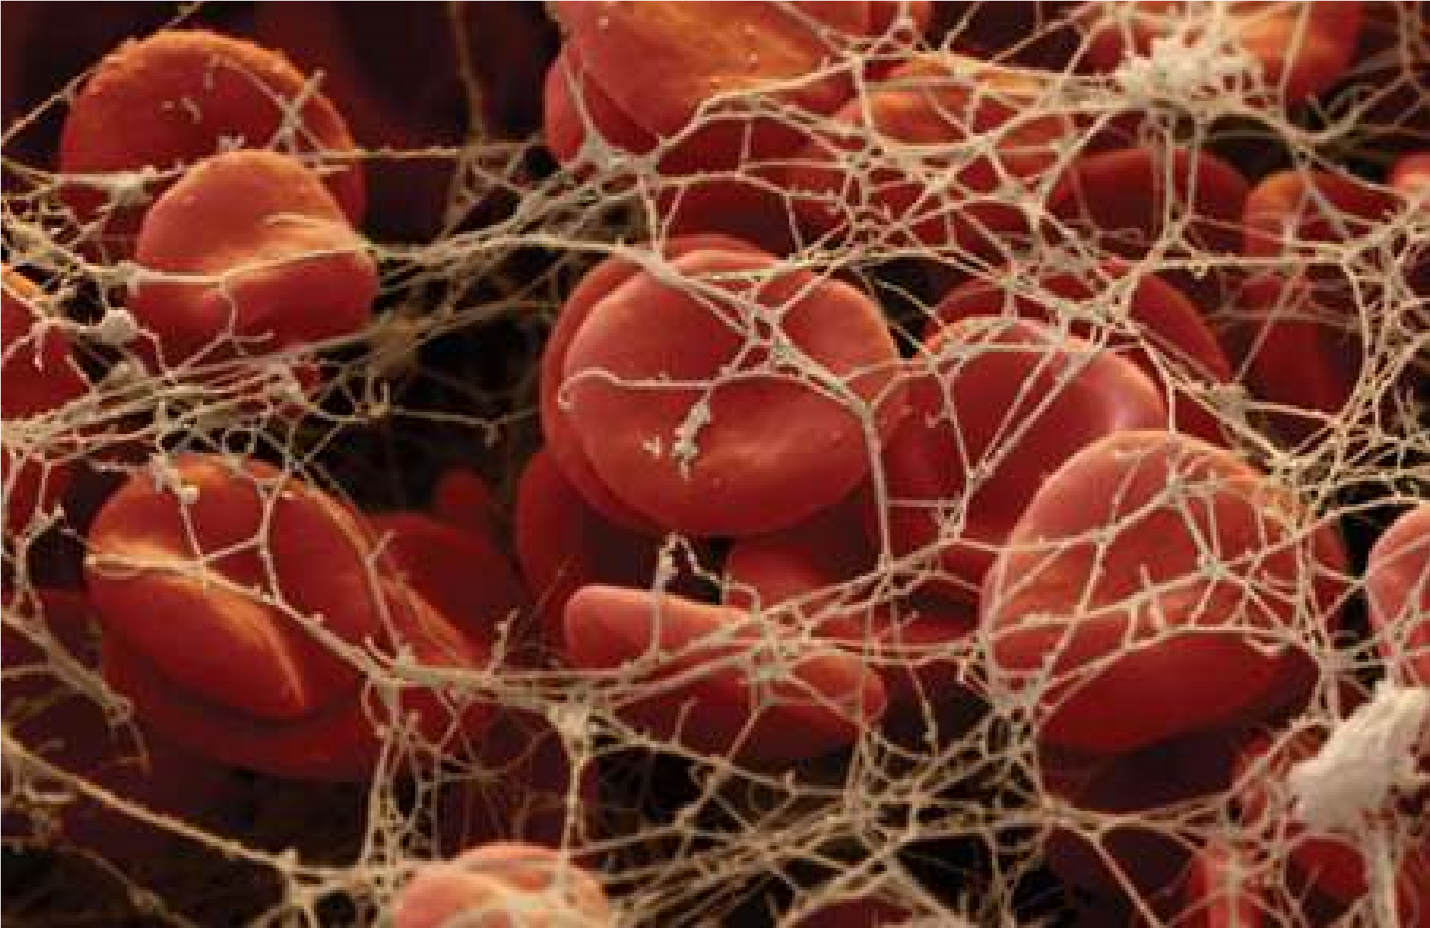

*Fig. 14.23 Blood clotting*

*Animation 14.12: Blood Cells*

*Source & Credit:* [*imgur*](http://imgur.com/gallery/0JGPsWt)

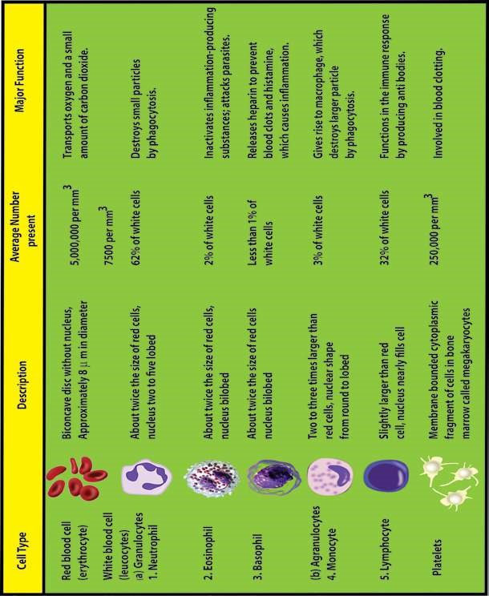

Leucocytes protect the body against foreign invaders, and use circulatory system to travel to the site of invasion. Monocytes and neutrophils travel through capillaries and reach the site of wound where bacteria have gained entry. Macrophages and neutrophils feed on bacterial invaders or other foreign cells, including cancer cells (Fig. 14.21). They typically die in the process, and their dead bodies accumulate and contribute to the white substance called pus, seen at infection sites.

Basophils produce heparin - a substance that inhibits blood clotting. These also produce chemicals, such as histamine, that participate in allergic reactions and in responses to tissue damage and microbial invasion. Lymphocytes help to provide immunity against the disease.

**(c) Platelets :** These are not cells, but are fragments of large cells called megakaryoctyes (Fig. 14.22). There is no nucleus in them. There is no pigment in them. Platelets help in conversion of ibrinogen, a soluble plasma protein, into insoluble form, ibrin. The ibrin threads enmash red blood cells and other platelets in the area of damaged tissue, ultimately forming a blood clot. The clot serves as a temporary seal to prevent bleeding until the damaged tissue can be repaired (Fig.

14.23).

**Functions of blood**

The overall functions of blood in humans can be listed as follows:

1. The plasma proteins maintain colloid osmotic pressure of the blood (75% by albumins, 25% by globulins and almost none by ibrinogen).
2. Blood helps to transport materials, in the body including nutrients, water, salts and waste products. All hormones are transported by blood from the endocrine tissues to the target cells.

1. Gases O2 and CO2 are transported by blood.
2. Blood helps in body defenses against disease, neutrophils and monocytes engulf and destroy invading microorganisms e.g. bacteria.
3. Blood provides immunity by the lymphocytes (pages 325-327).
4. Blood produces interferon, and antitoxins which are proteins, and protects our body from nucleic acids and toxins of invading organism.
5. Blood acts as a bufer to maintain the acid - base balance i.e. concentration of H+ and OH ions of the body.
6. Helps in maintaining the body temperature, concentration of water and salts, thus helps in homeostosis.
7. Wall of Blood helps in the exchange of materials between blood and body tissue through blood capillaries via interstitial luid.
8. Blood helps the body in maintaining the internal environment, by producing heparin, histamines, and also maintaining the amounts of chemicals including water and salts, in the body and maintains body temperature to a constant or nearly constant levels.
9. Helps in blood clotting process and seals the wounds, that stop entry of pathogens into body.

### DISORDERS

There are certain disorders, related to the blood. Some of them are discussed below: **i) Leucaemia (Blood Cancer)**

It is the result of uncontrolled production of white blood cells (leucocytes). This is caused by a cancerous mutation of a myelogenous or lymphogenous cell. The Leucaemia is usually characteriszed by greatly increased numbers of abnormal white blood cells in the circulating blood. Myelogenous cells (bone marrow cells) are in the bone marrow - and may spread throughout the body, so that white blood cells are produced in many other organs. These white blood cells are not completely diferentiated, and so are defective. Leucaemia may be of diferent types depending on the type of white blood cells, which are undiferentiated and being produced at a faster, than normal rate. There may be neutrophilic leucaemia, eosinophilic leucaemia, basophilic leucaemia, monocytic or lymphocytic leucaemia. It is a very serious disorder and the patient needs to change the blood regularly with the normal blood, got from donors. It can be cured by bone marrow transplant - which is in most cases efective, but very expensive treatment.

#### ii) Thalassaemia (G. Thalassa = The sea; haema = blood)

It is also called Cooley’s anaemia on the name of Thomas B. Cooley, American pediatrician. It is a genetically transmitted haemoglobin abnormality. It is characterized by the presence of microcytes, by spleenomegaly (enlargement of spleen) and by changes in the bones and skin. The blood of these patients is to be replaced regularly, with normal blood. It can be cured by bone marrow transplant - which is very expensive - and does not give 100% cure rate. Haemoglobin molecule in most cases, does not have (b- chains in it, instead F.chain is present (F is foetal haemoglobin).

#### iii) Oedema

It means the presence of excess luid in the tissues of the body. The excess luid may be in the cells, or outside the cells. The intracellular oedema is caused by osmosis of water into the cells, and cause, depression of metabolic systems (due to lack of nutrition and O2 in the tissues) especially and the Na-pump.

The extracellular oedema may be the result of :

1. Abnormal leakage of luid from the blood capillaries or failure of the lymphatic system to return luid from the interstitial luid.
2. Oedma is caused by renal retention of salts and water. Oedema disturbs the exchange and concentration of minerals and ions in the blood and body cells, afects blood pressure, increases heart load etc.

#### (B) Pumping Organ - The Heart

**Structure and action :** The heart of humans is located in the chest cavity. The heart is enclosed in a double membranous sac - the pericardial cavity, which contains the pericardial luid. Pericardium protects the heart, prevents it from over extension.

The wall of the heart is composed of three layers.

(i) **Epicardium** (ii) **Myocardium** (iii) **Endocardium**

Myocardium of the heart is made up of special type of muscles, the cardiac muscles.

These muscles contain myoibrils, and myoilaments of myosin and actin. Their arrangement is similar to those in skeletal muscle ibres, and their mechanism of contraction is essentially the same, except that they are branched cells, in which the successive cells are separated by junctions called intercalated discs. The heart contracts automatically with rhythmicity, under the control of the autonomic nervous system of the body.

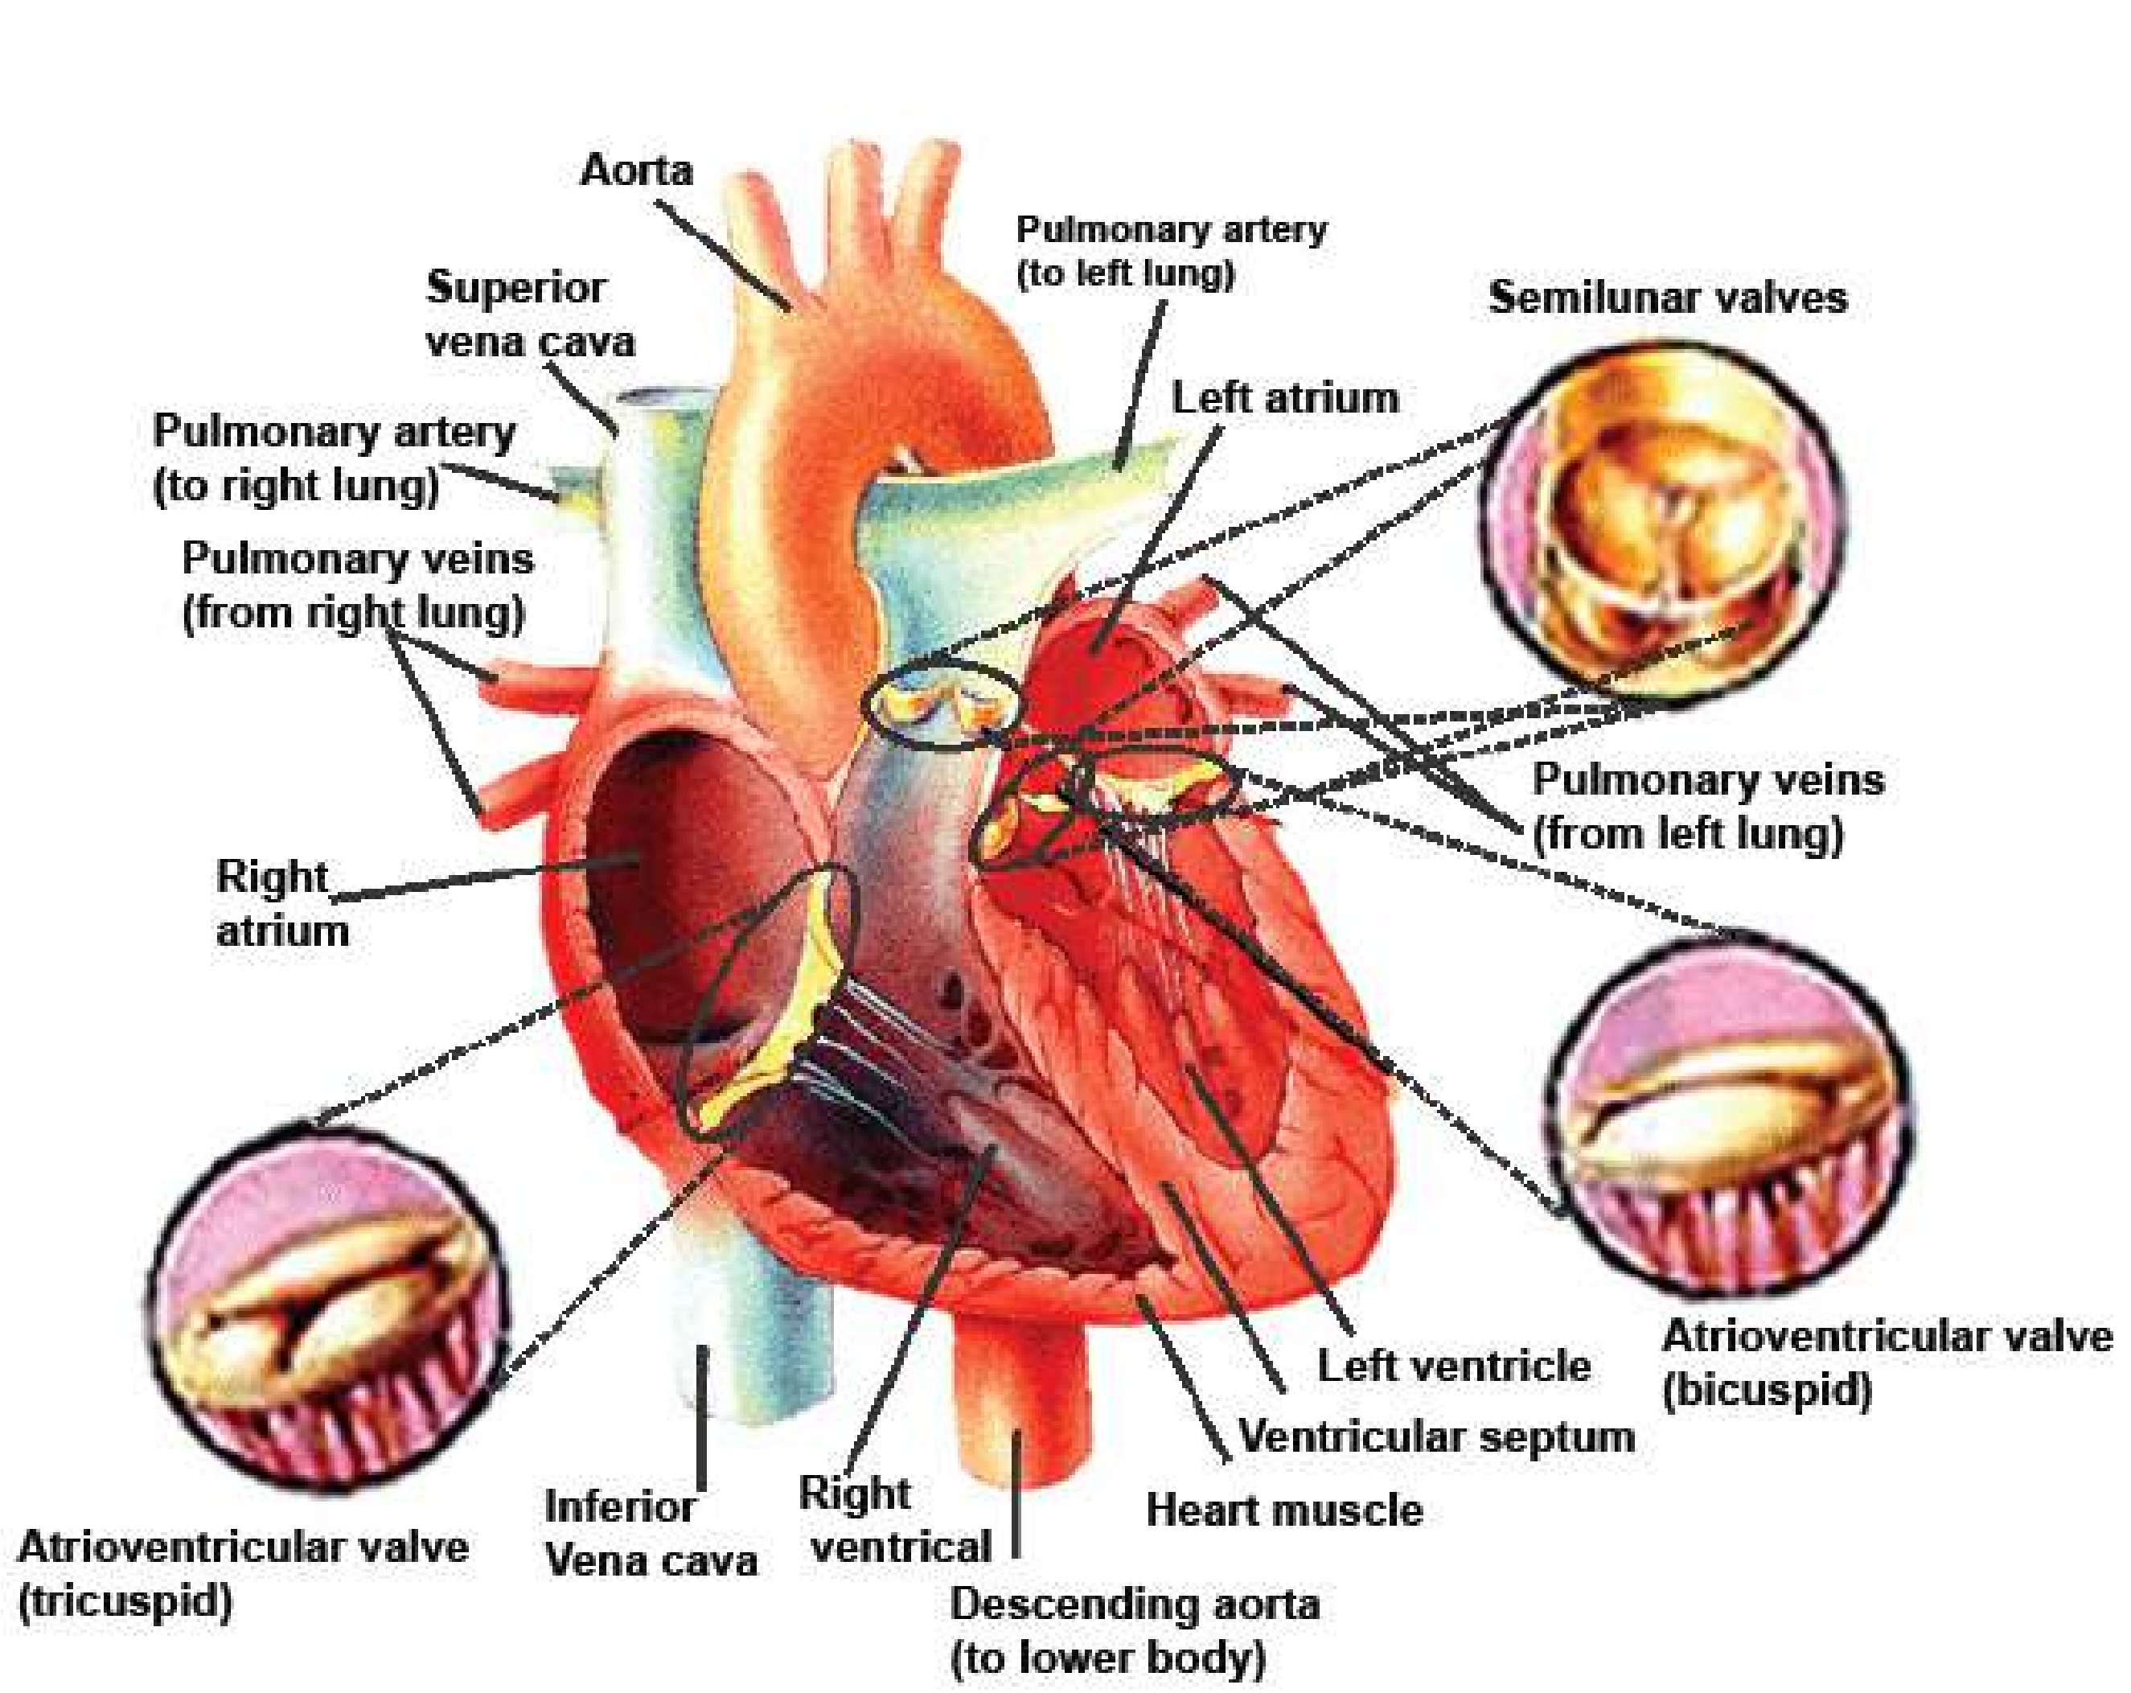

*Fig 14.24 The human heart and its valves and vessels.*

There are four chambers of the heart: two upper thin-walled atria, and two lower thick walled ventricles. Human heart functions as a double pump, and is responsible for pulmonary and systemic circulation. Complete separation of deoxygenated blood (Right side) and oxygenated blood (left side), in the heart, is maintained. The right atrium receives deoxygenated blood via venae cavae from the body.

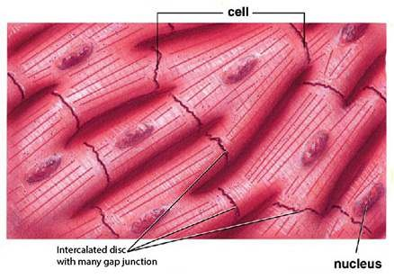The blood is passed on to right ventricle through tricuspid valve (called so because it has 3 laps). These laps are attached with ibrous cords called chordeae tendinae, to the papillary muscles which are extensions of the wall of the right ventricle. When right ventricle contracts, the blood is passed to pulmonary trunk, which carries blood via left and right pulmonary arteries, to the lungs. At the base of the pulmonary trunk, semilunar valves are present. After oxygenation in lungs the blood is brought by pulmonary veins to the left atrium, which passes this blood via bicuspid valve (called so because it has two laps) to the left ventricle. The laps of bicuspid valve are similarly attached through chordae tendinae, to papillary muscles of the wall of left ventricle. When the left ventricle contracts, it pushes the blood through aorta to all parts of the body (except lungs). At the base of aorta semilunar valves are also present. The valves of the heart control the direction of low of blood. The wall of left ventricle is thicker (about 3 times) than that of the right ventricle. At the base of aorta, irst pair of arteries, the coronary arteries, arise, and supply blood to the heart. The aorta forms an arch, and before descending down gives three branches supplying blood to head, arms and shoulders. The aorta descends down in the chest cavity. It gives many small branches to the chest wall and then passes down to the abdominal region. Here it gives branches, which supply blood to diferent parts of alimentary canal, kidneys

and the lower abdomen. *Fig.14.25 The structure of cardiac muscle*

The aorta Bifurcates into iliac arteries, each of which leads to supply blood to each legs. The blood from the upper part of the body is collected by diferent veins, which join to form superior vena cava; which pass its blood to the right atrium. Two **Iliac veins** are formed by veins which collect blood from legs, and unite to from inferior **vena cava**. It receives **renal vein** from each kidney; and **hepatic vein** from the liver, before it enters the right atrium. The liver receives **hepatic portal vein** which is formed by many veins collecting deoxygenated blood with absorbed food from diferent parts of alimentary canal.

#### The Cardiac Cycle

It is the sequence of events which take place during the completion of one heart beat. Heart beat involves three distinct stages (Fig. 14.26).

**1. Relaxation phase - diastole.**

The deoxygenated blood enters right atrium through vena cava, and oxygenated blood enters left atrium through pulmonary veins. The walls of the atria and that of ventricles are relaxed. As the atria are illed with blood, they become distended and have more pressure than the ventricles. This relaxed period of heart chambers is called diastole.

##### 2. Atria Contract - atrial systole

The muscles of atria simultaneously contract, when the atria are illed and distended with blood, this is called atrial systole. The blood passes through tricuspid and bicuspid valves, into the two ventricles which are relaxed.

##### 3. Ventricles contract - ventricular systole

When the ventricles receive blood from atria, both ventricles contract simultaneously and the blood is pumped to pulmonary arteries and aorta. The tricuspid and bicuspid valves close, and ‘lubb’ sound is made. Ventricular systole ends, and ventricles relax at the same time semilunar valves at the base of pulmonary artery and aorta close simultaneously, and ‘dubb’ sound is made. (Lubb, dubb can be heard with the help of a stethoscope).

One complete heart beat consists of one systole and one diastole, and lasts for about 0.8 seconds.

In one’s life, heart contracts about 2.5 billion times, without stopping.

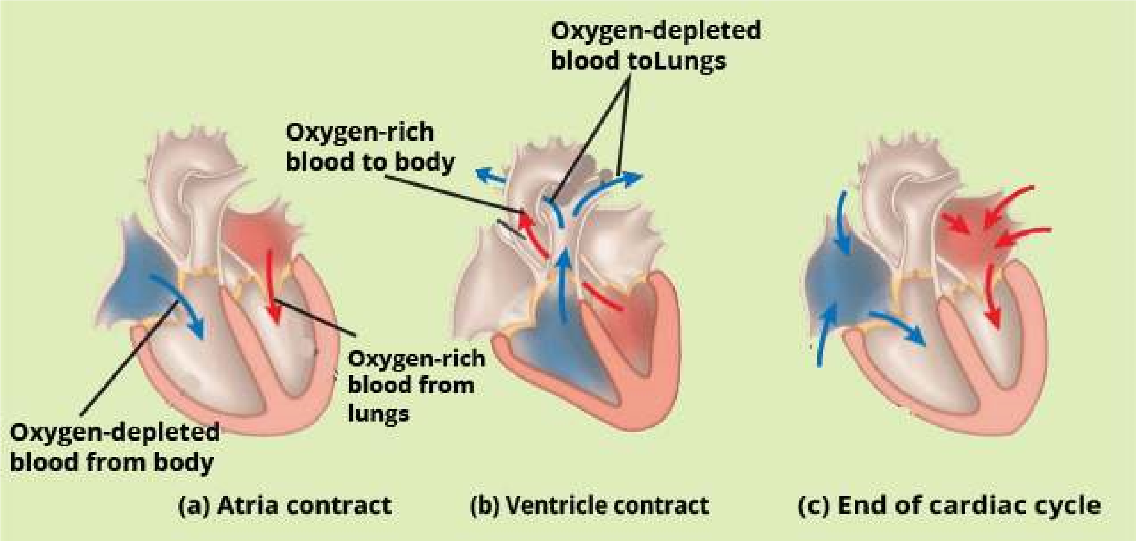

*Fig.14.26 The cardiac cycle*

##### Mechanism of heart Excitation and Contraction

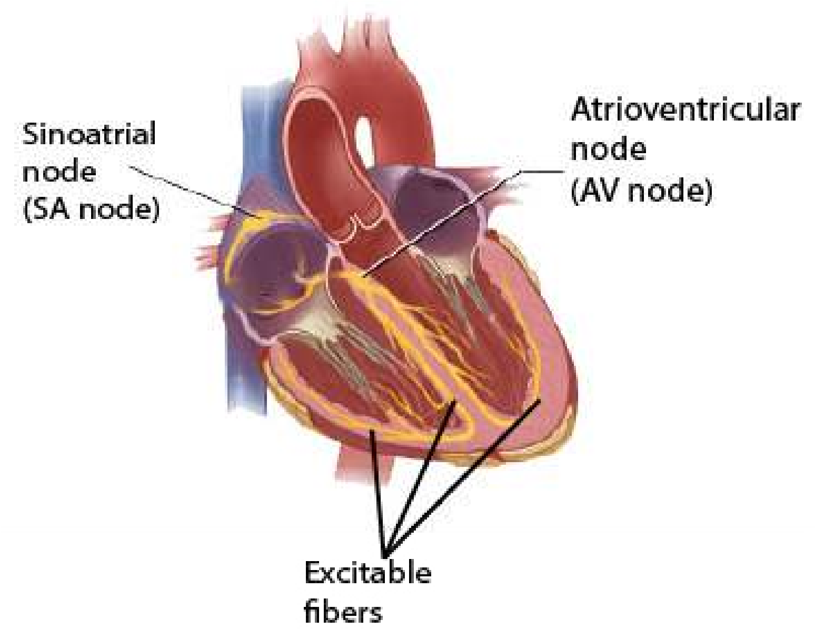The heart beat cycle described above starts when the sino-atrial node (Pace maker) at the upper end of right atrium sends out electrical impulses to the atrial muscles, and causing both atria to contract. The sino-atrial node consists of a small number of difusely oriented cardiac ibres, possessing few myoibrils; and few nerve endings from the autonomic nervous system.

Impulses from the node travel to the musculature of the atrium and to an atrioventricular node. From it an atrioventricular bundle of muscle ibres propagates the regulatory impulses via excitable ibres in interventricular septum, to themyocardium of the ventricles. There is a delay of approximately 0.15 second in conductance from the S-A node to A-V node, permitting atrial systole to be completed before ventricular systole

begins (Fig. 14.28). *Fig.14.27 The heart’s pacemaker and its connections*

*Animation 14.13: Heart pacemaker*

*Source & Credit:* [*thevisualmd*](http://www.thevisualmd.com/panel/?c=V45.01)

##### Electrocardiogram

As the cardiac impulse passes through the heart, electrical currents spread into the tissues surrounding the heart, and a small proportion of these spread all the way on the surface of the

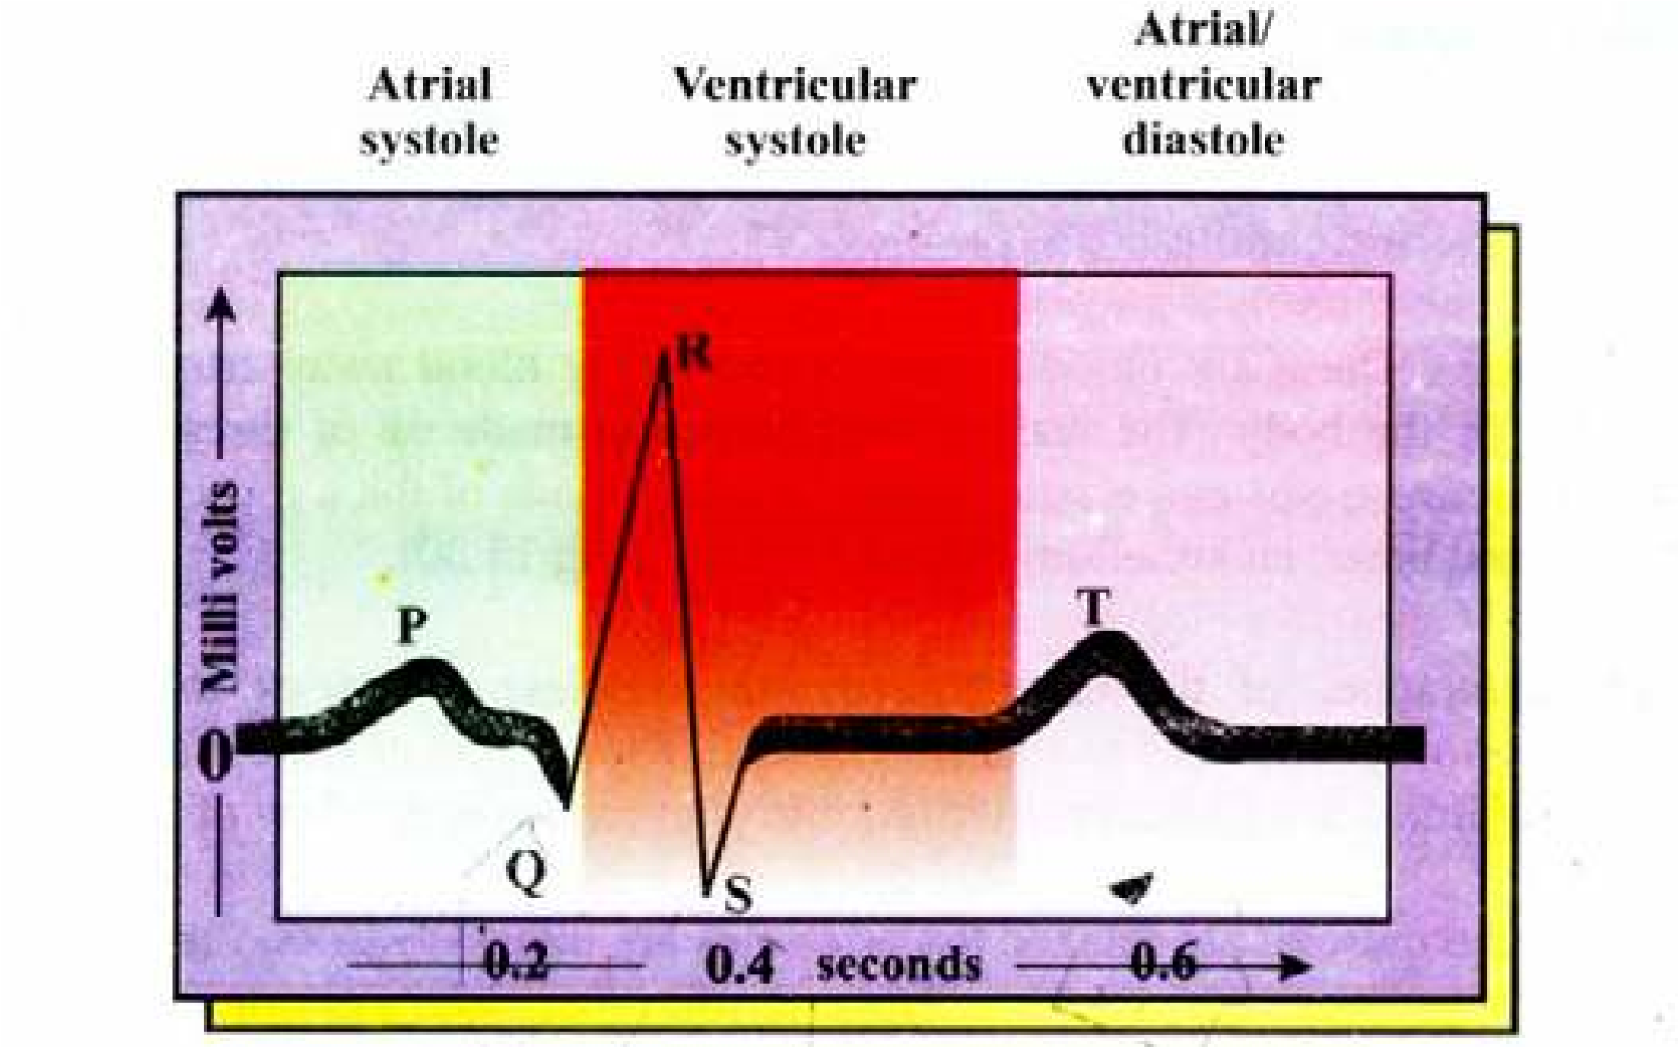

A normal electrocardiogram (ECG) indicates that the heart is functioning properly. The P wave occurs just prior to atrial contraction; the QRS wave occurs just prior to ventricular contraction and the T wave occurs when the ventricles are recovering from contraction.

body. If electrodes are placed on the skin on opposite sides of the heart, electrical potentials generated by these currents can be recorded. This recording is known as electro cardiogram which is taken by electrocardiograph (E.C.G.) machine. It helps to diagonose the abnormalities in the rhythmicity and conduction system of the heart which may be corrected by the use of artiicial pacemaker.

##### Artiicial pace maker

Pacemaker is responsible for initiating the impulses which trigger the heart beat rate. If there is some block in the low of the electrical impulses, or if the impulses initiated by S.A. node are weak; it may lead to death of the individual. So an artiicial pacemaker, which is battery operated producing electrical stimulus is used. For example if A-V pathway is blocked, the electrodes of artiicial pacemaker are attached to the ventricle. Then this pacemaker provides continued rhythmic impulses that take over the control of the ventricles.

###### Blue babies

Failure of interatrial foramen (an opening in the inter-atrial septum) to close or of ductus arteriosus to fully constrict results in cyanosis (blueness of skin) of new bom. This is due to mixing of blood between two atria and the mixed blood is supplied to the body of newborn babies resulting in blueness of skin, thus the name blue babies.

#### (C) Blood vessels

The third component of the blood circulatory system of humans comprises of the blood vessels; arteries, capillaries and veins.

1. **Arteries :** These are blood vessels which carry blood away from the heart to diferent parts of the body. The wall of the arteries is made up of three layers, outer, (made of connective tissue and elastic ibres), middle (made of thick muscular tissue and elastic ibres) and inner, endothelium (Table 14-3, and Fig 14.30).

The contraction of the circular (smooth muscles) of arteries and arterioles is under the control of nervous and endocrine systems. When stimulated the muscle contracts, constricting the arterioles (vasoconstriction) and thus reducing the low of blood in them.

When the muscles are relaxed the arterioles are dilated (vasodilation) more blood lows in them, The arterioles themselves divide repeatedly until they form a dense network of microscopic vessels, called capillaries.

**Atherosclerosis** (G. athere = porridge; skeleoris = hardening): It is coexisting atheroma and arteriosclerosis; atheroma is deposition of hard yellow plaque of lipoid material in the inner most layer of the arteries, which may be due to high level of cholesterol in the blood.Arteriosclerosis is a degenerative arterial change associated with advancing age. Primarily a thickening of middle layer of arteries, and usually associated with some degree of atheroma. So Atherosclerosis causes narrowing and hardening of arteries. This increases the risk of formation of thrombus (see thrombus formation), and if thrombus is formed in the brain or heart it is fatal. (Atherosclerosis is a major condition leading to heart attack.

1. **Capillaries :** These are blood vessels with walls that are only one cell thick (Table 4.3, Fig. 14.29, 14.30). Although the blood appears conined within the capillary walls, the latter are permeable with the result, that water and dissolved substances pass in and out exchanging oxygen, carbon dioxide dissolved food and excretory products with the tissues around capillary. The capillary network is so dense that no living cell is far from a supply of oxygen and food. In the liver, every cell is in direct contact with a capillary. The diameter of a capillary can be altered by nervous stimulation, which tends to close them, and by chemicals, such as histamine, which dilate them. The change in diameter is brought about by a change in the shape of the cells, constituting their walls. The pre capillary sphincters also regulate the amount of blood lowing in capillaries. Thus the amount of blood lowing in a certain tissue is controlled.

The capillaries are the sites where the materials are exchanged between the blood and body tissues. This exchange occurs in three ways.

1. Active transport and difusion through the cells lining the capillary wall into the interstitial or extracellular luid, and then to the body cells, and vice versa.
2. Through the intercellular spaces of endothelial lining of wall of capillary to and from the extracellular luid.
3. Materials from the cavity of capillaries are also taken up by endocytosis, and then passed to the other side by exocytosis. Same is true for some materials entering from the interceullar spaces (extracellular luid) into the blood.

Thus the exchange of materials takes place between blood and tissues via extracellular or interstitial luid. Capillaries join to form venules, which join to form veins.

**(iii) Veins :** These blood vessels transport blood from body cells towards heart. The wall of veins has same three layers as are present in arteries. But middle layer is relatively thin and only slightly muscular, with few elastic ibres, (table 14.3 and Fig. 14.30). The semilunar valves are present in the veins. These valves prevent the back low of blood, as it is moving towards the heart. The pressure of surrounding muscles, when they contract, tends to squash the veins and assist the return of blood towards heart.

Veins join to form larger veins, and ultimately form venae cavae (Inferior vena cava and superior vena cava) which pour the blood into the right atrium of the heart. The oxygenated blood from the lungs is brought to the left atrium by pulmonary veins.

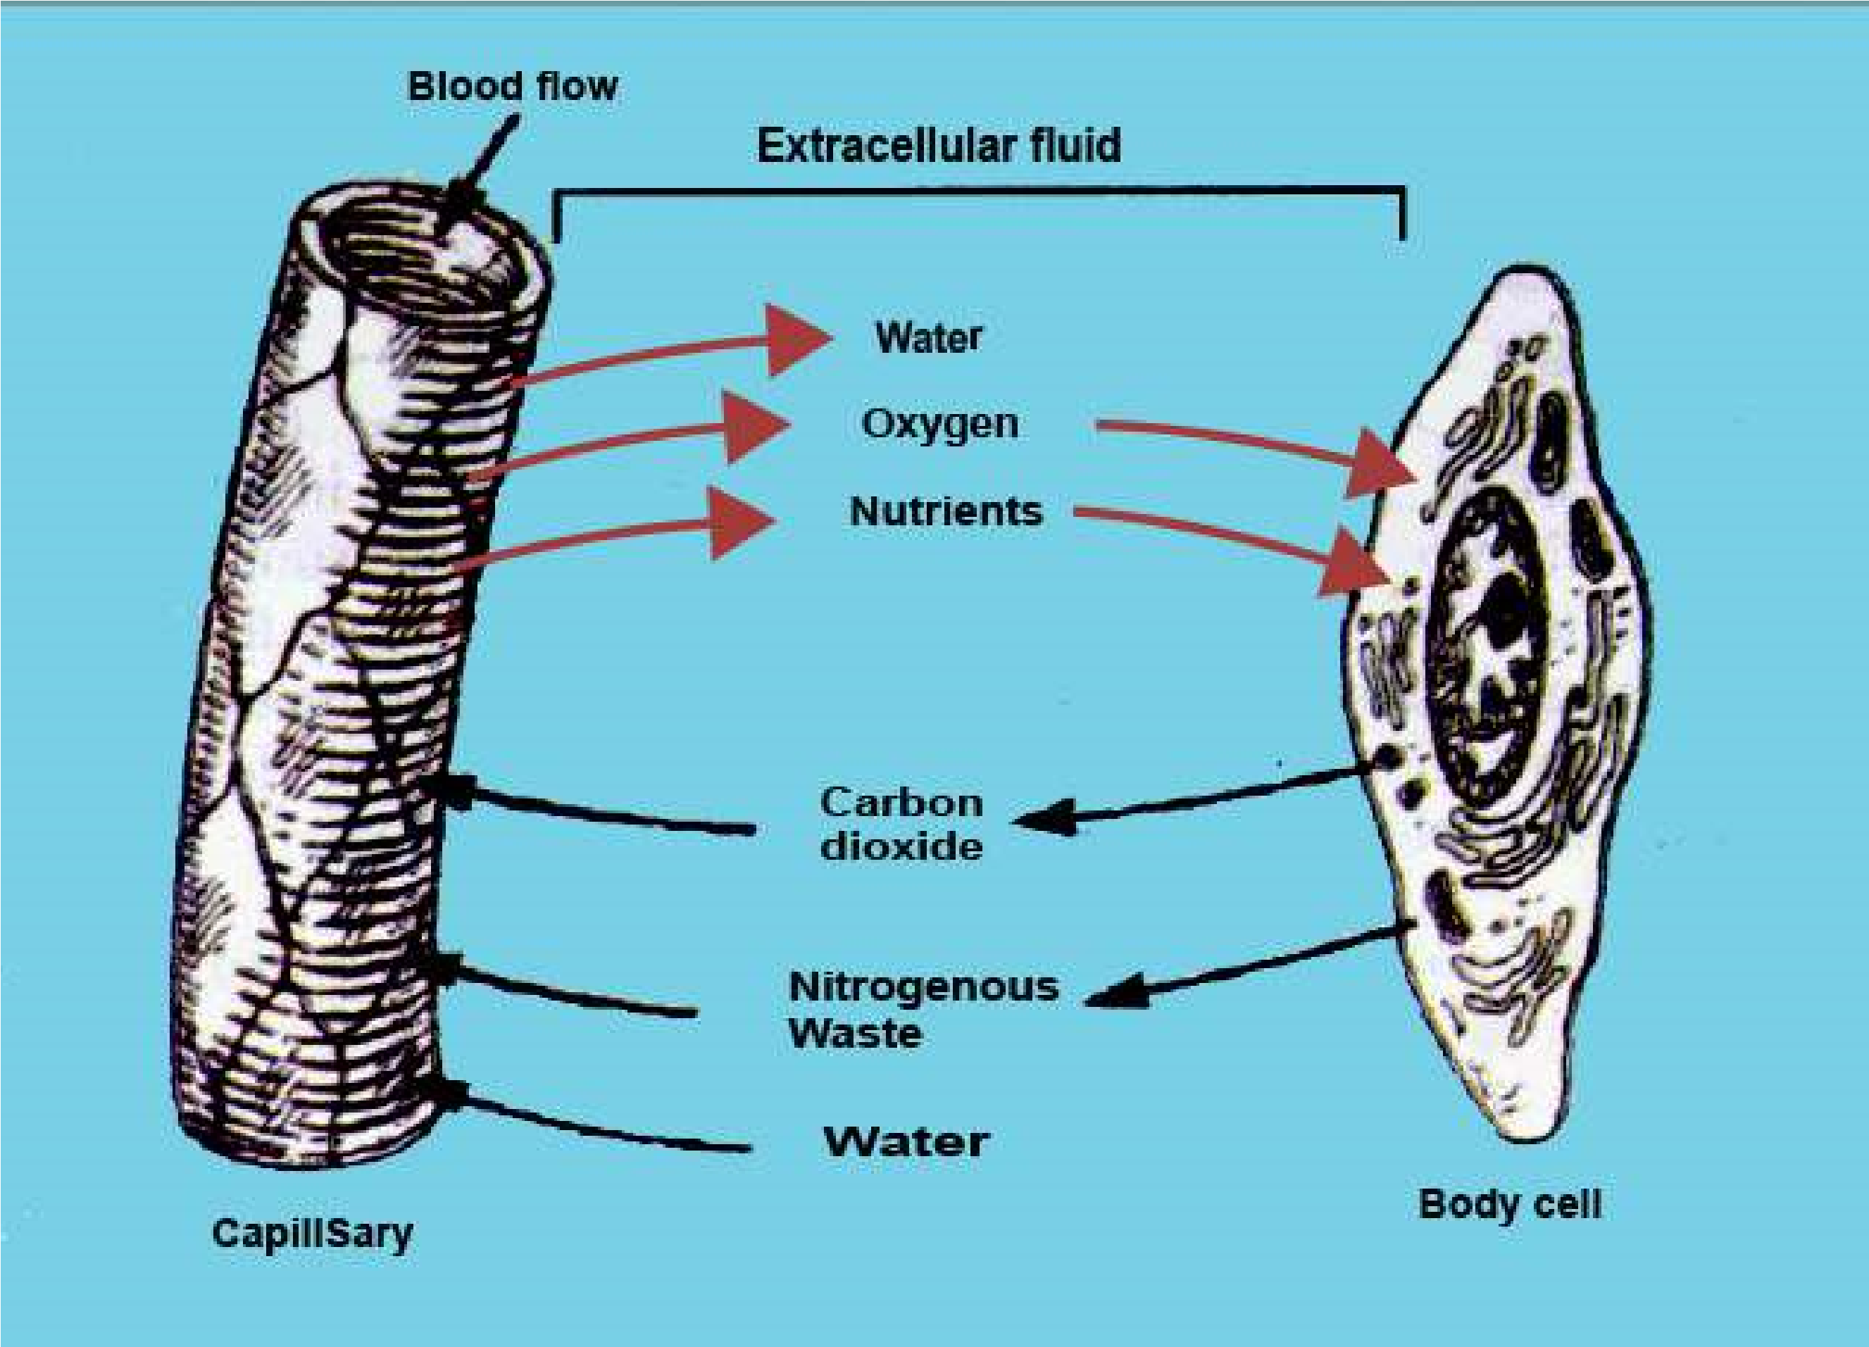

*Fig.14.29 The exchange of gases and nutrients in a capillary.*

The pressure within capillaries causes a continuous leakage of luid from the blood plasma into the spaces that surround the capillaries and tissues. This luid, known as interstitial luid consists primarily of water, in which the dissolved nutrients, hormones gases, wastes, and small proteins from the blood are present. Large proteins red blood cells and platelets cannot cross the intercellular spaces of capillary wall, so they remain within capillaries. But some white blood cells can squeeze out through the intercellular spaces of capillary wall. Interstitial luid is the medium through which the exchange of materials between the blood and nearby cell occurs. (Fig. 14.29)

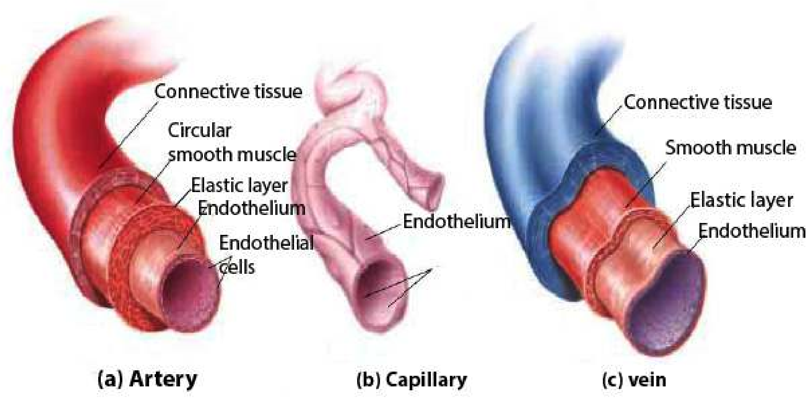

*Fig.14.30 Showing the comparison in structure of artery, capillary and vein.*

*Animation 14.14: Structure of artery*

*Source & Credit: my-ecoach*

Table 14.3 Comparison in structure and function of an artery, capillary and vein

|  |  |  |
| --- | --- | --- |
| **Arteries** | **Veins** | **Capillaries** |
| 1. These transport blood away from the heart to the various parts of the body through capillaries. | 1. These collect blood from body through capillaries and transp ort it towards heart. | 1. These link arteries with veins. |
| 2. All arteries carry oxygenated blood except pulmonary arteries. | 2. All veins carry deoxygenated blood except pulmonary veins. | 2. These have mixed oxygenated and deoxygenated blood. |
| 3. There are no valves in them except at the base of pulmonary trunk and aorta. | 3. Valves are present. These prevent the back low of blood. | 3. There are no valves. |
| 4. Have high blood pressure. | 4. Have low blood pressure. | 4. Falling pressure in these. |
| 5. Wave of blood pressure or pulse due toheartbeat can be detected. | 5. No pulse. | 5. No pulse. |
| 6. Blood low rapid. 400-500mm per second in aorta and decreasing in arteries and arterioles. | 6 . Rate of blood low increases from smaller to larger veins. | 6. Blood low slowest less than 1 mm per second. |
| 7. Have smaller bore and thick wall. | 7. Have larger bore and thin walls. | 7. Larger bore; wall one cell in thickness. |
| 8. Thick muscle layer and elastic ibres present. The elasticity helps changing the pulsating low of blood. | 8. Thin muscle layer and less elastic ibres. So they are less elastic. | 8. No muscles or elastic ibres. |
| 9. No exchange of materials. | 9. No exchange of materials. | 9. Responsible for exchange of materials. |

##### Blood Pressure and Rate of low of Blood

It is the measure of force with which blood pushes up against the walls of blood vessels. It is the force that keeps blood lowing from the heart to all the capillary networks in the body. This pressure is generated by the contraction of ventricles (ventricle systole) and is the highest in aorta, then gradually reduces in arteries. The walls of arteries are elastic and the low of blood stretches them, and it is felt as pulse. During diastole, the relaxation phase of the cardiac cycle, the heart is not exerting pressure on the blood in the arteries and pressure in them falls. The pressure reaches its high point during systole (systolic pressure which in normal individuals is 120 mm Hg) and its low point during diastole (diastolic pressure which in normal individuals ranges between 75-85 mm Hg). The blood pressure gradually declines (Fig. 14.31). The decline of the blood pressure in successive parts of systemic circuit, is the result of friction between the lowing blood and the walls of the blood vessels - thus blood moves from a region of higher pressure towards a region of lower pressure.

Several other changes occur along the route of blood low.

1. The diference between systolic and diastolic pressure continues to diminish until it disappears in the capillaries and veins.
2. The rate of blood low tends to fall as the blood moves through the branching arteries and arterioles, the rate is lowest in the capillaries; and increases again in the venules and veins. These changes in rate of blood low result from changes in the total cross sectional area of the vessel system. The low of blood in veins is maintained by the contraction of surrounding muscles and the action of semilunar valves which prevent back low of blood. Muscular activity including breathing movements help normal low of blood in the body.

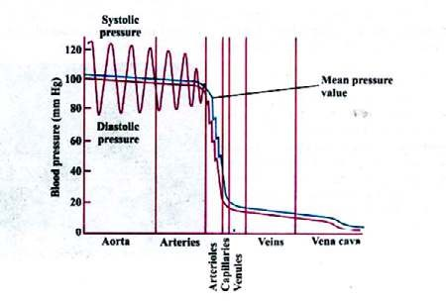

*Fig.14.31(a) graph of blood pressure in diferent parts of the human circulatory system.*

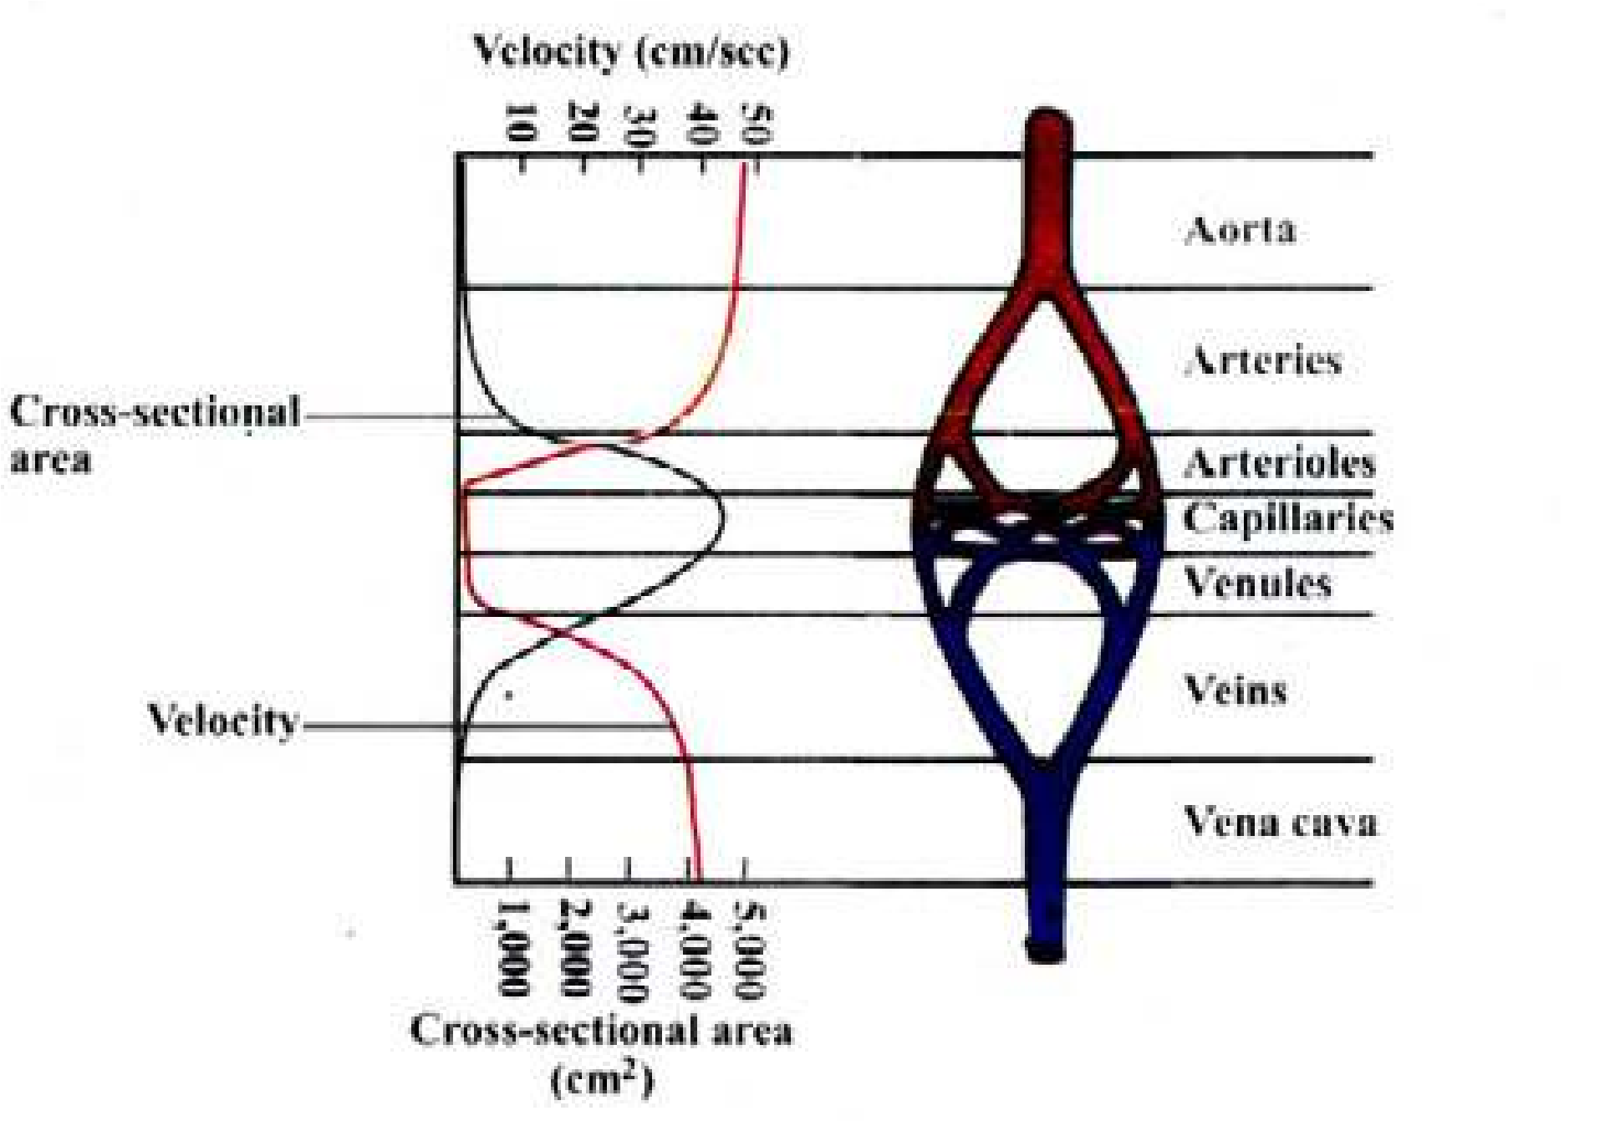

*Fig.14.31 (b)Change in the velocity of blood low in the various parts of a systemic circulatory pathway.*

###### Hypertension

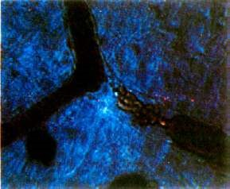It is a condition of high blood pressure. Prolonged high blood pressure damages the lining of the blood vessels and also leads to weakening of heart muscles (which have become thickened due to the continuous strain imposed on them), with declining eiciency of the pumping action of the heart. Blood may then be retained in the heart and lungs, often leading to fatal condition called congestive heart failure.

###### Thrombus Formation and Hypertension

Thrombus is a solid mass or plug of blood constituents (clot) in a blood vessel. This mass may block (wholly or only in part) the vessels in which it forms, or it may be dislodged and carried to some other location in the circulatory system, in which case it is called an embolus. Thrombosis is the formation of thrombus (Fig. 14.32). Thromboembolism is leading cause of deaths in western civilization.

*14.32 A thrombus in a small blood vessel. The thrombus (tangled red mass) has blocked blood low near a point where the vessel branches. The blood has pulled away from the left end of the thrombus and is beginning to pull away from the right end also.*

Thrombus formation may be due the following:

i) Irritation or infection of lining of blood vessels. ii) Reduced rate of blood low, due to long periods of inactivity.

iii) Pneumonia and tuberculosis, emphysema

Heart attack (Myocardial infarction)

Blockage of blood vessel in the heart by an embolus (or by locally formed thrombus) causes necrosis or damage to portion of heart muscles, a condition known as a heart attack or technically myocardial infarction, Heart attack is due to disruptions of control system of the heart with accompanying arrhythmias, especially ventricular ibrillation.

We can avoid the above mentioned situations if we :

1. Avoid too much fatty food (especially rich in cholesterol). Maintain normal body weight.
2. Control blood pressure by regular walk and exercise.iii) Do not smoke.

Stroke

If the normal low of blood is blocked by an embolus (or a locally formed thrombus), in a blood vessel in the brain, and causes necrosis, or death, of the surrounding neural tissue (owing to lack of O2), the condition is called a stroke or cerebral infarction. The symptoms of the stroke vary depending on the part of the brain that has been damaged.

Haemorrhage

It is the discharge of blood from blood vessels. Especially important is the brain haemorrhage which results from bursting of any of the arteries supplying the brain. When the wall of the arteries becomes hard and loses its elasticity - and higher blood pressures would result in brain haemorrhage. To avoid brain haemorrhage, the blood pressure must be controlled between normal limits.

In almost all the above mentioned problems, it is important to take following preventive measures :

* Taking in of less cholesterol in our food. Maintenance of normal blood pressure.
* Do not become over weight.
* Do not smoke.
* Do regular exercise.
* Avoid stress and tension.

### LYMPHATIC SYSTEM

This system is responsible for the transport and returning of materials from the tissues of the body to the blood.

The system comprises lymph capillaries, lymph vessels, lymphoid masses, lymph nodes, and **lymph**the luid which lows in the system.

Lymph capillaries end blindly in the body tissues, where pressure from the accumulation of interstitial luid or extracellular luid forces the luid into the lymph capillaries. When this luid enters the lymph capillaries, it is called lymph. The lymph vessels empty in veins; so lymph is a luid in transit between interstitial luid and the blood.

The intercellular spaces in the walls of lymph vessels are larger than those of the capillaries of blood vascular system. So larger molecules, from the interstitial luid can also enter the lymph capillaries.

Lymph capillaries join to form larger and larger lymph vessels; and ultimately form thoracic lymph duct, which opens into subclavian vein. The low of lymph is always towards the thoracic duct.

In the intestine, the branches of lymph capillaries, within villi, are called lacteals.

The low of lymph is maintained by :

Activity of skeletal muscles, movement of viscera, breathing movements and the valves, which prevent back low of lymph.

Along the pathway, the lymph vessels have, at certain points, masses of connective tissue where lymphocytes are present; these are **lymph nodes**. Several aferent lymph vessels enter a lymph node, which is drained by a single, eferent lymph vessels.

Lymph nodes are present in the neck region, axilla and groin of humans.

In addition, several lymphoid masses are present in the walls of digestive tract, in the mucosa and submucosa. The larger masses spleen and thymus, tonsils and adenoids are all lymphoid masses. These produce lymphocytes.

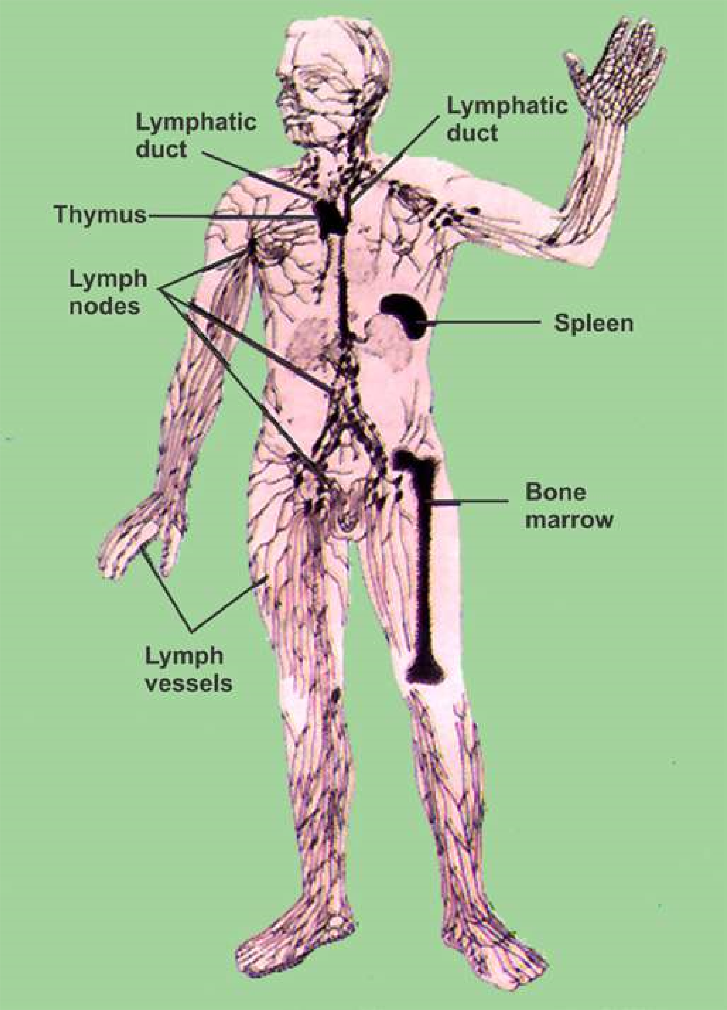

*Fig. 14.33 Human lymphatic system.*

There are the several functions performed by lymphatic system.

1. In an average person, about three litres more luid leaves the blood capillaries than is reabsorbed by them each day. It returns this excess luid and its dissolved proteins and other substances to the blood.
2. The lacteals of villi absorb large fat globules, which are released by interstitial cells after the products of digestion of fats are absorbed. After a fatty meal these fat globules may make up 1% of the lymph.
3. The lymphatic system helps defend the body against foreign invaders. Lymph nodes have lymphocytes and macrophages that destroy bacteria and viruses. The painful swelling of lymph nodes in certain diseases (mumps is an extreme example) is largely a result of the accumulation of dead lymphocytes and macrophages.

iv ) Just as the lymph nodes ilter lymph, the spleen ilters blood, exposing it to macrophages and lymphoctyes that destroy foreign particles and aged red blood cells.

### IMMUNITY - AND ITS TYPES

#### Immunity

The capacity to recognize the intrusion of any material foreign to the body and to mobilize cells and cell products to help remove the particular sort of foreign material with greater speed and efectiveness” is called **immunity**.

In animals in addition to physical barriers (skin + mucous membranes) and phagocytes, there is a third mechanism, to defend their bodies against the foreign

invaders; this is the **immune system**. *Lymphocyte T and B have been named due to their relationship with Thymus gland, and*

*Bursa of Fabricius respectively. The inluence*

The components of immune system include the lymphocytes *of the thymus gland essential in making*

(B and T) and the antibodies - which are special type of proteins. *T-cells immunologically competent.Bursa ofFabricius is lymphoid structure present in*

These antibodies are immunoglobulins which are synthesized *the wall ofcloaca of young birds from where* by vertebrates, in response to antigens; and immobilise it, or *B-lymphoctyes were discovered to have role* sets in motion events that ultimately cause its destruction. *in immune system.*

**Antigen or immunogen** is a foreign substance, often a protein which stimulates the formation of antibodies (Fig. 14.34) **Antibodies** are speciic i.e. cause the destruction of the antigen, which stimulated their production. **Antibodies** are manufactured in B-lymphocytes , then secreted in to the lymph and blood where they circulate freely.

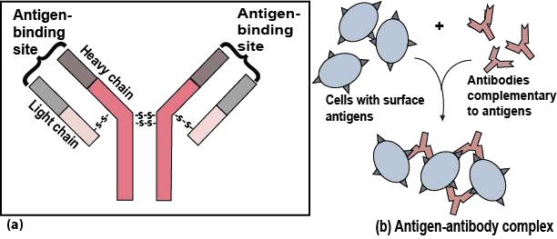

*Fig. 14.34 (a) An antibody molecule consists of four polypeptide chains - two identical light chain and two identical heavychains - linked by disulide (- S - S -) bridges. Variable amino acid sequences (V) in the light chains and upper regions of the heavy chains determine which antigen will bind to that particular antibody. Constant amino acid sequences (C) are the same for all the antibodies in one class (b) Large antigen-antibody complexes will form if there are multiple copies of the antigenic molecule on the foreign cell’s surface.*

T-cells recognize antigen, then combat micro-organisms and / or efect the rejection of foreign tissues (in case of tissue transplant). This is called **cell-mediated response.**

B-cells recognize antigen and form plasma cell clone. These plasma cells synthesise and liberate antibodies into the blood plasma and tissue luid. Here antibodies attach to the surfaces of bacteria and speed up their phagocytosis, or combine with and neutralise toxins produced by microorganisms, by producing antitoxins. This is called **humoral Immune response.**

When we get vaccination, against a speciic disease (antigen), we become immune to that infection or disease. If we get vaccination against, polio, smallpox, measles, mumps etc., once in our life time, we are protected or become immune to that infection in our future life.

#### Types of immunity

**Active Immunity :** The use of vaccines, which stimulate the production of antibodies in the body, and making a person immune against the disease or infection, is called **active immunity.** But this active immunity has been achieved by artiicially introducing, antigens in the body, so it is called **artiicially induced active immunity.**

But, when a person is exposed to an infection (antigen) - becomes ill, and in *Antiserum is a* most cases survives then this immunity, developed against that disease is called *serum containingantibodies.* **naturally induced immunity or auto immune response.**

**Passive immunity :** In contrast to active immunity, in which case antigens are introduced to stimulate the production of antibodies, by artiicial or natural method; antibodies are injected in the form of antisera, to make a person immune against a disease,This is called **passive immunity.**

In body, antigen - antibody complexes are formed which are taken up by phagocytes and destroyed. The patient is spared the complications (or possibly death) caused by the infection or venom.

Passive immunity response is immediate, but not long lasting. Because no time is taken for the production of suicient level of antibodies, (as antibodies are being injected) and after the level of antibodies is reduced or they are used up - No more antibodies production is there. The method of passive immunization

**AIDS** *(Acquired Immune Deiciency Syndrome;*

is used to combat active infections of, *is a disease caused by a virus. The afected persons sufer from* tetanus, infectious hepatitis, rabies, snake *deiciency in their immun system of the body, and the immune system* bite venom etc. In the case of snake bite *or cancer, that under normal circumstances, the immune system cancollapses. Thus the* **AIDS** *victim often succumb to a bacterial disease* venom passive immunity is produced by the *over come. There is no known cure of the disease. It can spread by* antitoxins so the serum is called antivenom *blood transfusion and by sexual contact with the infected persons.* serum.

#### EXERCISE

1. **.1 Fill in the blanks :**
   * 1. In the process of facilitated difusion, the carrier molecules are......................................

* + 1. Pure water has a water potential which is equal to .....................................
    2. The insects which feed on the phloem of plants are the ................................
    3. The substance produced by basophils which inhibits blood-clotting is ............................
    4. The most abundant compound of blood plasma of man i s .........................
    5. ........................ in 1874 suggested that water molecules move along the cells walls of xylem vessels due to imbibition.

* 1. **Write whether the statement is ‘true’ or ‘false’ and write the correct statement if it is false.**
     1. The intercellular openings in the blood capillaries are larger than the openings in the lymph capillaries.
     2. Between the left auricle and the left ventricle in human heart, the valve present is called tricuspid valve.
     3. The pacemaker of the heart of man is the AV node.
     4. Each sieve tube member is associated with one or more tracheid cells.
     5. The method of active immunization is used to combat active infections of tetanus and rabies.
  2. **Extensive Questions**

1. How are minerals and water taken up by roots? Draw the structures involved and the pathways for water and minerals from soil water to xylem, and the transport processes at each step.
2. Describe the mechanism of opening and closing of stomata.
3. How does the pressure-low theory explain the movement of sugars through a plant?
4. Describe cohesion-tension theory of water movement in xylem. What supplies the cohesion, and what is the source of tension? How do these two forces interact to move water through

plant,

1. Explain, apoplast, symplast and vacuolar pathways, and describe the movement of water and dissolved minerals, through them.
2. Explain water potential. What is the relationship of water potential with solute potential and pressure potential?
3. Name and describe the general functions of the three major type of cells or cell like bodies found in blood of humans. Which of these cell types is found predominantly in lymph?

(ix) Write a note on immunity and its types.